# Get Sports Info

##### A MAJOR PROJECT REPORT

Submitted in partial fulfillment of the requirement for the award of Degree of Master of Computer Applications

Submitted to



**RAJIV GANDHI PRODYOGIKI VISHWAVIDYALAYA, BHOPAL (M.P.)**

**Submitted by:**

**Mr. Ashay jain**

**Enrollment No – 0827CA183D09**

**Under the Supervision of**

**Ms. Pushpa Pathak**



**MASTER OF COMPUTER APPLICATIONS ACROPOLIS INSTITUTE OF TECHONOLOGY & RESEARCH, INDORE**

**SESSION - 2019-20**

**BONAFIDE CERTIFICATE**

This is to certify that Major Project entitled **“Get Sports Info”** being submitted by **Mr./Ms. Ashay Jain (0827CA183D09)** for partial fulfillment of the requirement for the award of degree of **Master of Computer Applications** to **Rajiv Gandhi Proudyogiki Vishwavidyalaya, Bhopal (M.P.)** during the academic year 2019-20 is a record of bonafide piece of work, carried out by the student under my supervision and guidance in the **Department of Computer Applications, AITR, Indore.**

##### (Prof. Geeta Santosh)

###### Professor & HOD, MCA

**(Internal Examiner) (External Examiner)**

**Date: Date:**

**COMPANY CERTIFICATE**

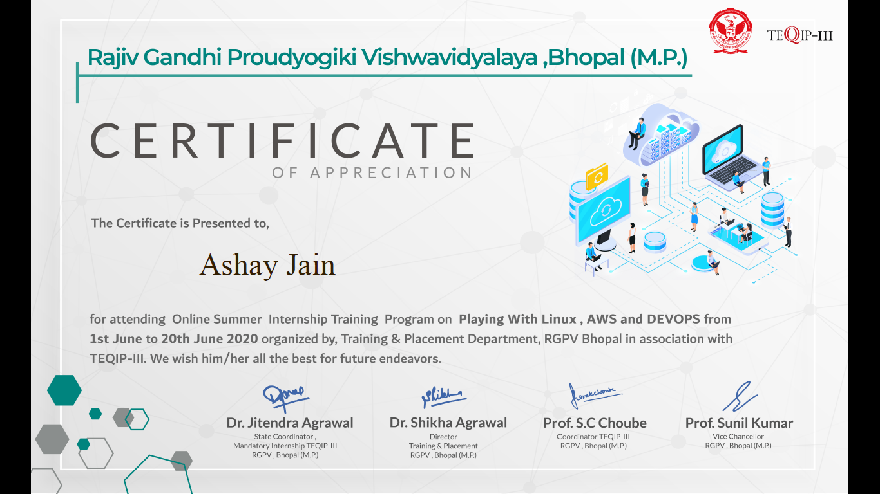

**ABSTRACT**

Playing any sports is good for physical and mental health of every individual persons but sometime people didn’t know what they can achieve and where to play or where they can learn the sports.

The main purpose of your website entitled as “Get Sports Info” is to encourage people to play sports.

For these we are creating your website which contain all the information of different sports right from best training center and best coaches, on one click user will find all the information of all different sports in a single site.

Your website includes

* Child development.
* History of sports.
* Importance of sports in life.
* Various sports information.
* Nearby sports training center.

## ACKNOWLEDGEMENT

The satisfaction that accompanies that the successful completion of any task would be incomplete without the mention of people whose ceaseless cooperation made it possible, whose constant guidance & encouragement crown all efforts with success.

We are grateful to our project guide Prof. Pushpa Pathak Madam for the guidance, inspiration and constructive suggestion that helpful as in the preparation of this project. We are also thanking to Prof. Geeta Santosh for helping us in the project. I also thank our colleagues who have helped in successful completion of the project.

**LIST OF TABLES**

**Table1. Login table Table2. Registration table**

**Table3. Corona table**

**LIST OF FIGURES**

**Figure 1: context level DFD Figure 2: 1st level DFD**

**Figure 3: Use Case Diagram of Get Sports Info**

**Figure 4: Use Case Diagram of user**

**List of Symbols, Abbreviations or Nomenclature (Optional)**

1. Dataflow
2. **Process **
3. **Source **
4. **Entity **
5. **Attribute **
6. **Relationship **
7. 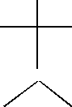**User**

|  |  |  |  |  |
| --- | --- | --- | --- | --- |
| s.no | Content | | | Page No. |
|  | Abstract | | | 4 |
|  | Acknowledgement | | | 5 |
|  | Table of Contents | | |  |
|  | List of Tables | | | 6 |
|  | List of Figures | | | 7 |
|  | List of Symbols, Abbreviations or Nomenclature | | | 8 |
| (Optional) | | |
| 1 | **Introduction** | | | 11-16 |
|  | 1.1 | Purpose | | 12 |
|  | 1.2 | Scope | | 13 |
|  | 1.3 | Definitions, Acronyms, and Abbreviations | | 14 |
|  | 1.4 | References | | 15 |
|  | 1.5 | Overview | | 16 |
| 2 | **System Analysis and General Description** | | | 17-19 |
|  | 2.1 | Feasibility study and Product perspective | | 17 |
|  |  | | 2.1.1 Technical | 17 |
|  |  | | 2.1.2 Economic |  |
|  |  | | 2.1.3 Behavioral |  |
|  | 2.2 | Product Functions | |  |
|  | 2.3 | User Characteristics | |  |
|  | 2.4 | General Constraints | |  |
|  | 2.5 | Assumptions and Dependencies | |  |
| 3 | **Design Descriptions and Requirements** | | | 20-38 |
|  | 3.1 | External Interface Requirements | |  |
|  |  | | 3.1.1User Interfaces |  |
|  |  | | 3.1.2Hardware Interfaces |  |
|  |  | | 3.1.3Software Interfaces |  |
|  |  | | 3.1.4Communications Interfaces |  |
|  | 3.2 | Product Study | |  |
|  | 3.3Functional Requirements | | |  |
|  |  | | 3.3.1 <Functional Requirement or Feature #1> |  |
|  |  | | 3.3.2 <Functional Requirement or Feature #2> |  |
|  | 3.4Use Case | | |  |
|  |  | | 3.4.1Use Case #1 |  |
|  | | |  | |



4.1

3.4.2Use Case #2

* 1. Non-Functional Requirements
     1. Performance 3.5.2Reliability
     2. Availability
     3. Security
     4. Maintainability
     5. Portability

3.6 DFD AND ER diagrams

**IMPLEMENTATION AND TESTING**

* 1. Implementation Constraints
  2. Testing
     1. Testing Methodology
     2. Test Cases

39-41

1. **CONCLUSION & FUTURE ENHANCEMENT**
   1. Appendices
   2. References
   3. **INTRODUCTION**

Playing any sports is good for physical and mental health of every individual persons but sometime people didn’t know what they can achieve and where to play or where they can learn the sports.

The main purpose of your website entitled as “GET SPORTS INFO” is to encourage people to play sports.

For these we are creating your website which contain all the information of different sports right from best training center and best coaches, on one click user will find all the information of all different sports in a single site.

Your website includes

* Child development.
* History of sports.
* Importance of sports in life.
* Various sports information.
* Nearby sports training center.
  1. Purpose

‘Get Sports Info’ would have the following key goals:

Provide the site member with an online interface to search for various type of material available in the library under different categories, which can be made accessible through the internet from anywhere in the world.

Provide the members with ability to select such material and invite some suggestion.

#### Scope

The scope of our project is only that User can find near by sports club and can make a healthy lifestyle with playing sports, we have also made a page on your website on corona prevention and symptoms of corona virus.

. The following few important scope of our project.

1. It can keep user information and their sports interest.
2. It can keep the Address of the all the nearby sports club.
3. If a user is unhealthy then we can submit information about this to us.

#### Definitions, Acronyms, and Abbreviations

DEFINATION:

Playing any sports is good for physical and mental health of every individual persons but sometime people didn’t know what they can achieve and where to play or where they can learn the sports.

The main purpose of your website entitled as “GET SPORTS INFO ” is to encourage people to play sports.

For these we are creating your website which contain all the information of different sports right from best training center and best coaches, on one click user will find all the information of all different sports in a single site.

Your website includes

* Child development.
* History of sports.
* Importance of sports in life.
* Various sports information.
* Nearby sports training center.

ACRONYMS:

GET: Get Sports Info

LM: Login Module

RUM: Registered Users Module

DB: Database

#### References

1. YouTube: <https://youtu.be/>
2. Google:www.google.com
3. <http://www.slideshare.net/>
4. https://[www.w3schools.com/](http://www.w3schools.com/)
   1. Overview

Get Sports info is a Website where user can register and login to access the website, by logging in user will have access to the website, user can find the benefits of playing sports, your website provide the near by one of the tops clubs of indore, your main propose for building this website is to make people aware of fitness and a healthy lifestyle

**2 SYSTEM ANALYSIS AND GENERAL DESCIPTION**

There are many people for the maintenance of your website, user can find his nearby sports center with the help of your website, we have taken small as well larges clubs so that users will be able to know every clubs in his nearby.

#### Feasibility Study and Product Perspective

The various system tools that have been used in developing both front end, back end and other tools of the project are being discussed in this section

###### Technical

The software is made with various languages and compatible to any of them. Software can be easily maintained and very secured it cannot easily corrupted or well tested. Here in below some description of technologies is given.

Front End

HTML, CSS, JAVA SCRIPTS are utilized to implement frontend. HTML (Hyper Text Markup Language)

HTML is a syntax used to format a text document on the web CSS (Cascading Style Sheets)

CSS is Style sheet language used for describing the look and formatting of a document written in a mark-up-language.

Java Script is a dynamic computer programming language. It is most commonly used as part of web browsers, whose implementation allow client-side scripts to interact with the user, control the browsers, communicate asynchronously, and alter the document content that is displayed.

BACK END

The backend is implemented using PHP, MYSQL which is used to design the databases.

MYSQL is the World’s second most widely used open source relational database Management system (RDMS) The SQL phrase stands for structured query.

###### Economic

The project is economically feasible because it is one-time investment product and the cost of maintenance is less than the papers that we are using in the written records.

#### Product Functions

The primary function of the **Get Sports Info** is that a user can register himself for the site and then he/she can access your website by login in, by doing so he/she will be able to find nearby sports clubs in the website.

The main idea behind the project is to make people aware about importance of sports in life.

#### User Characteristics

The user profile identified to have interaction with the **Get Sports Info** that anyone can register and login into system and us the required resources. The students can easily fill up the registration and submit it.

#### General Constraints

**Get Sports Info** can be accessed successfully by any client and it’s not necessary that every registration is genuine, so there is chances of fake registration that may reflect some errors. So the system is designed such a way that the database will keep updated by administrator and there is better security options available on the server that can prevent fake IP addresses to access system.

**3. DESIGN DESCRIPTION AND REQUIREMENT**

#### External Interface Requirements

* + 1. User Interface

**Get Sports Info** web server must provide a user interface that will be accessible through any internet browser, the major ones being Google Chrome and internet Explorer12.

#### Screenshorts

1. Home Page

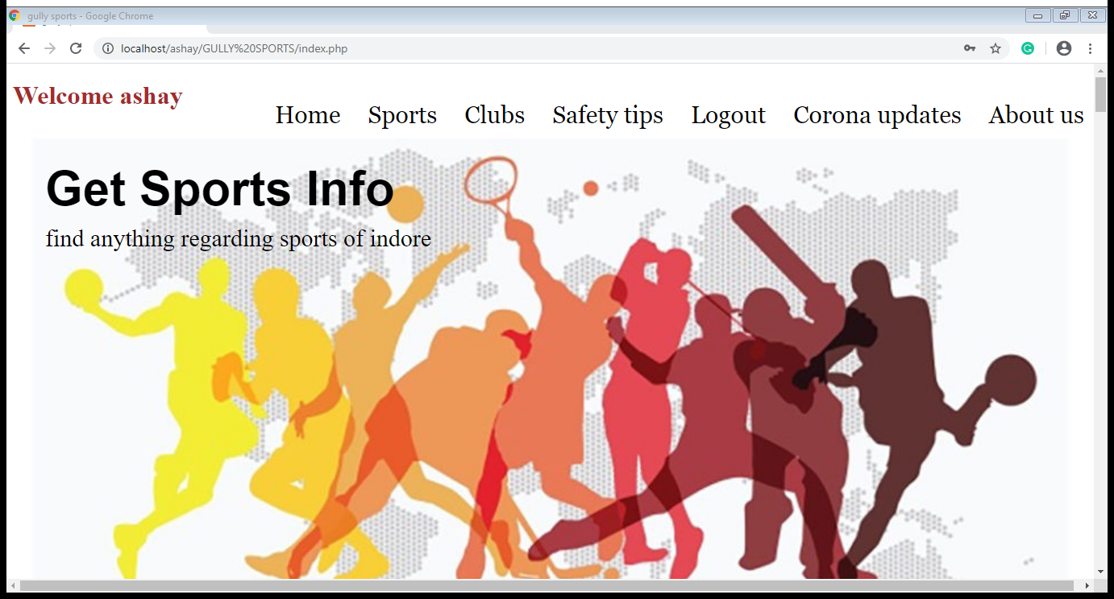

1. **REGITRATION FORM**

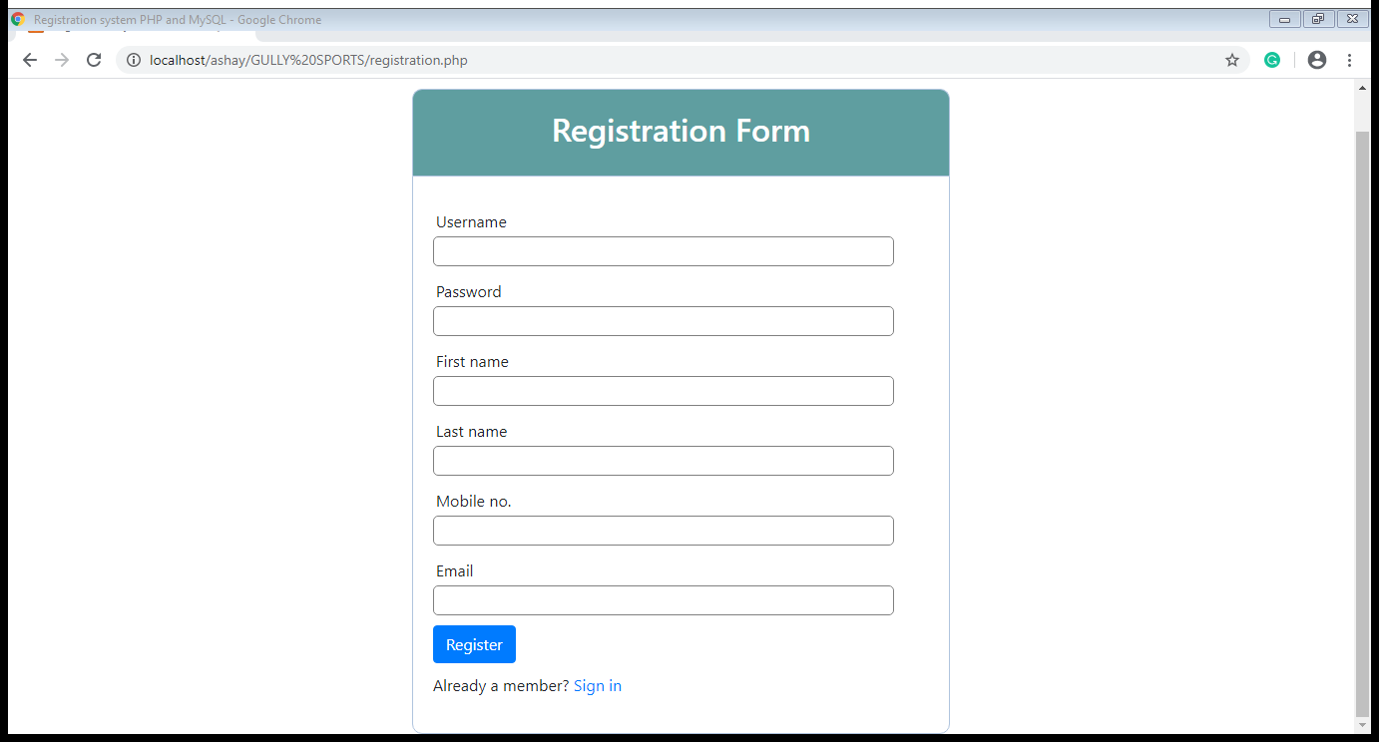

1. LOGIN FORM

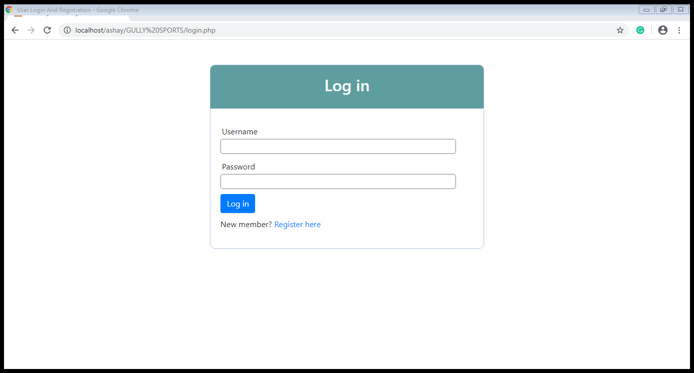

1. **SPORTS SECTION**

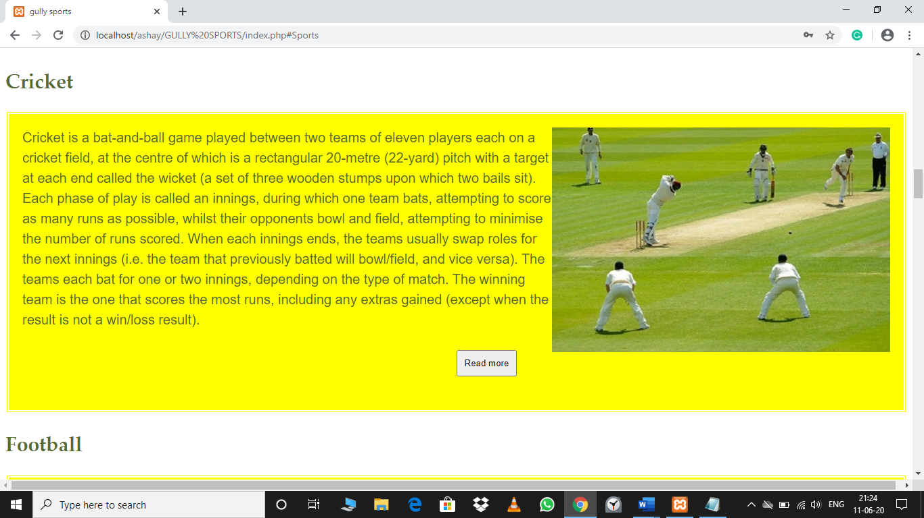

1. **SPORTS CATEGORIES**

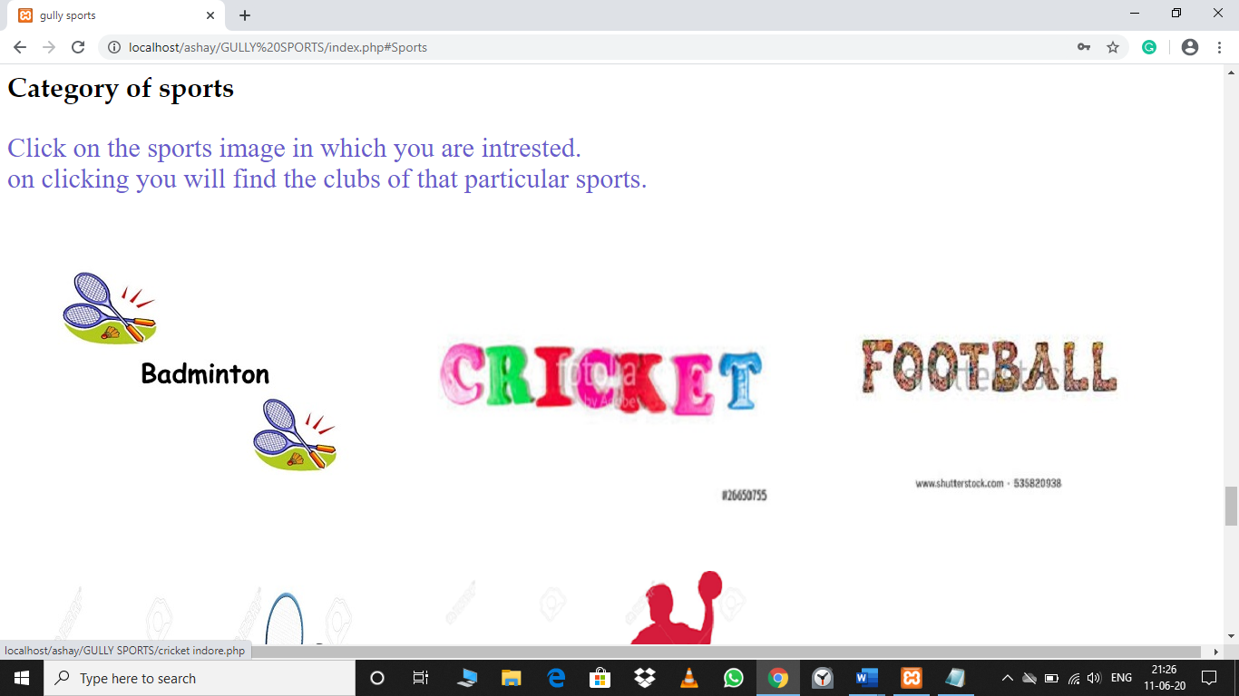

1. **SPORTS CLUB**

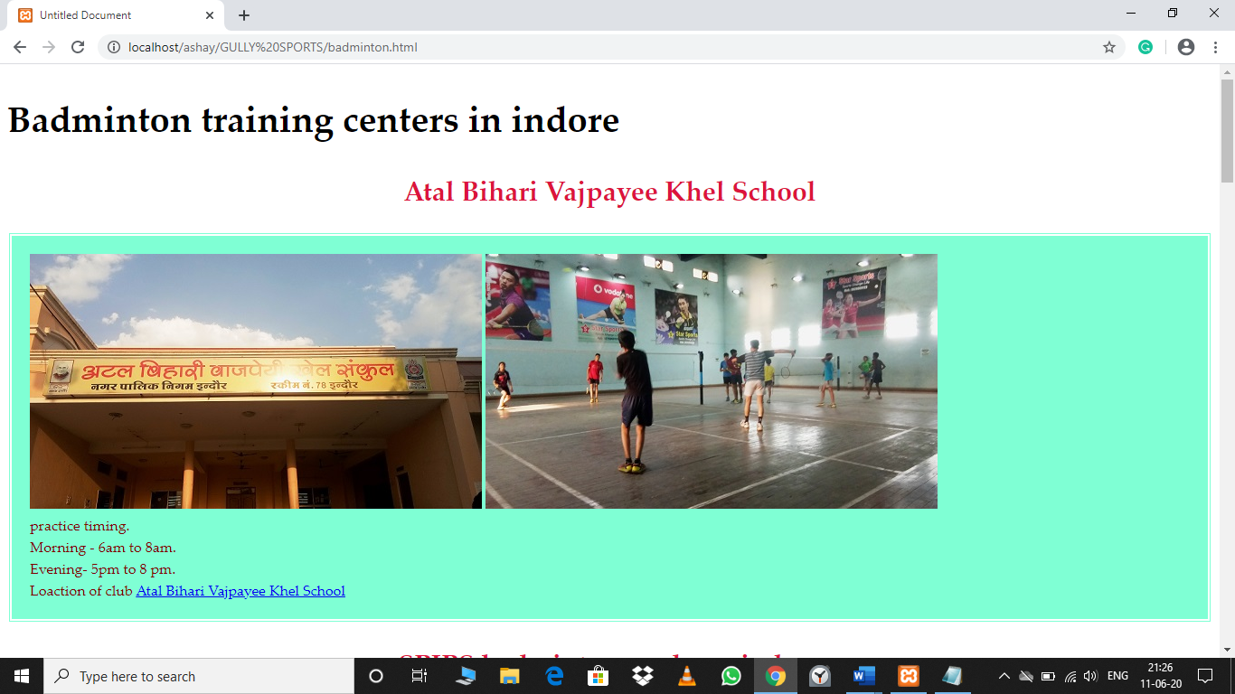

1. **SAFTEY TIPS**

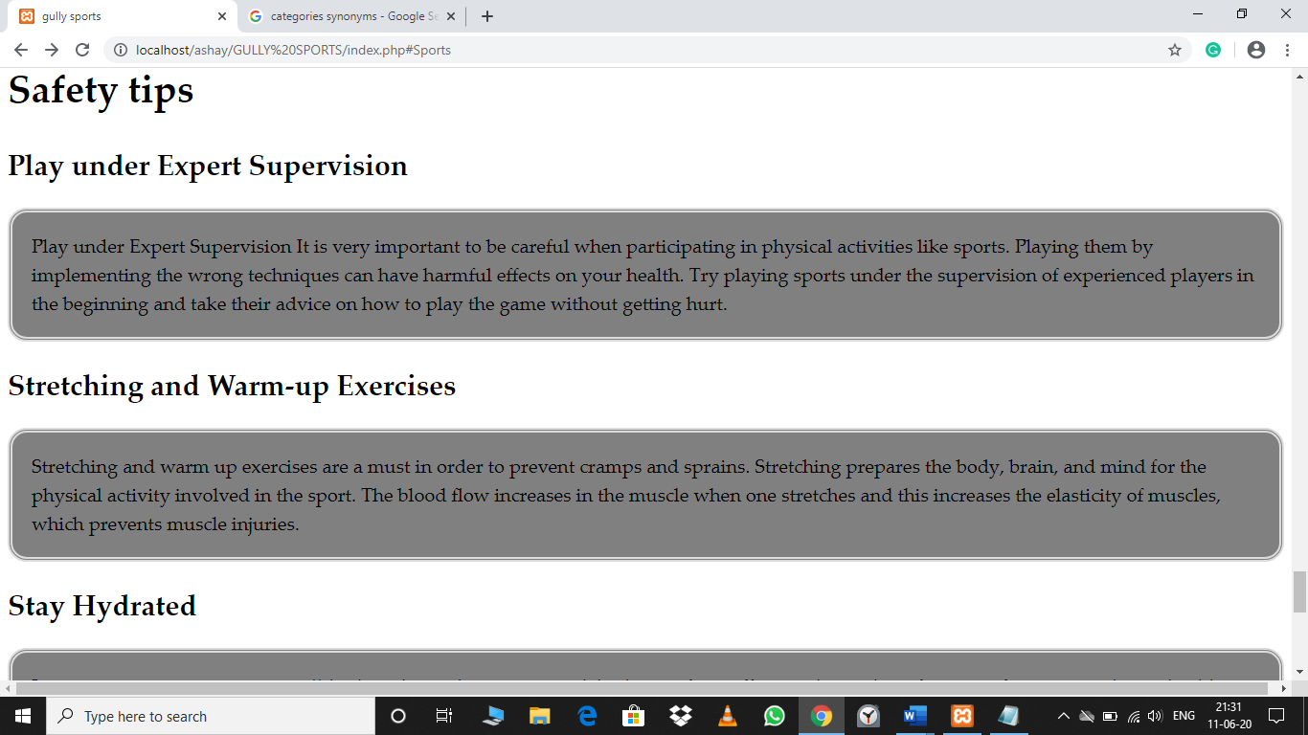

**8. ABOUT US**

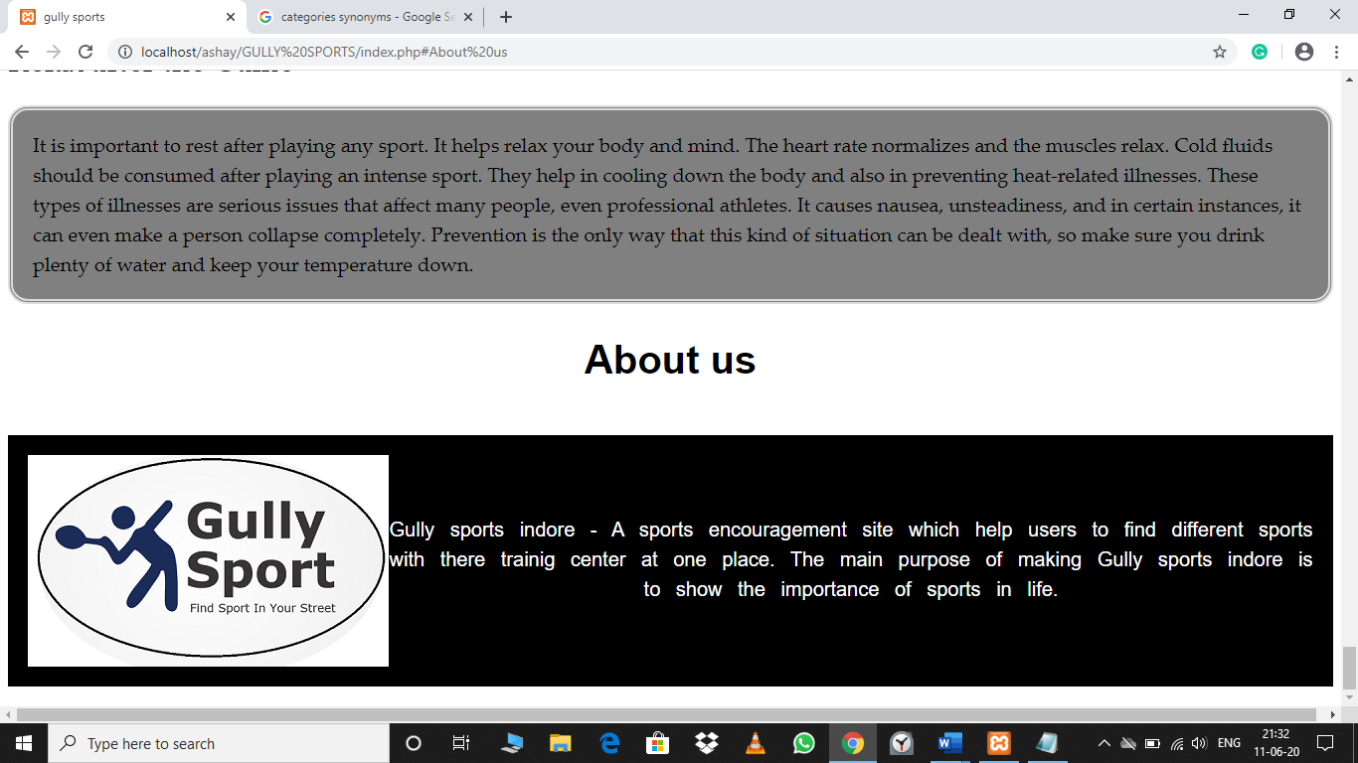

**9. CORONA PAGE**

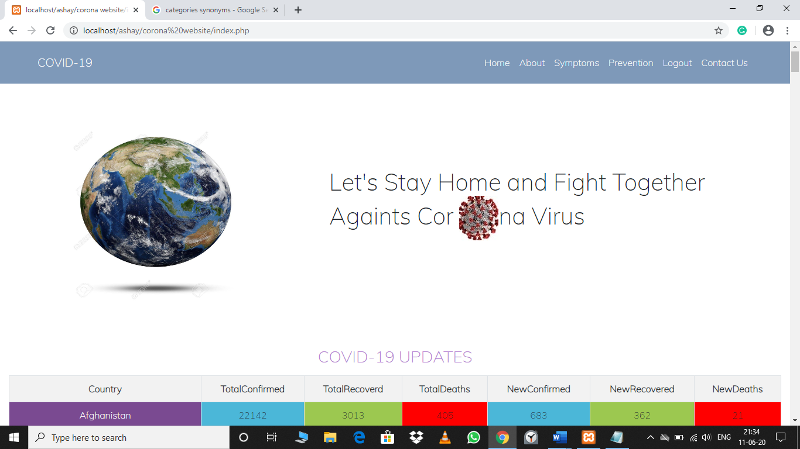

10. COVID 19 LIVE UPDATES

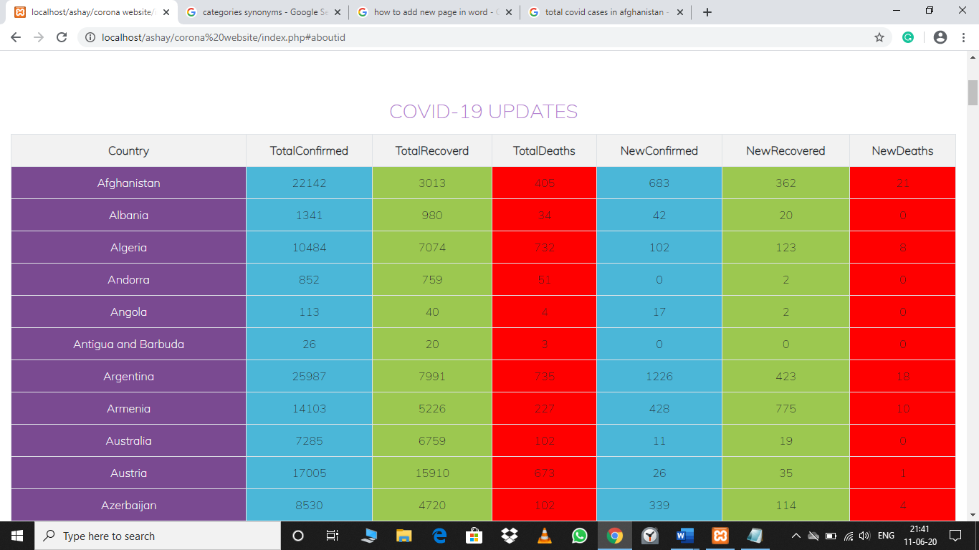

**11. CONTACT US**

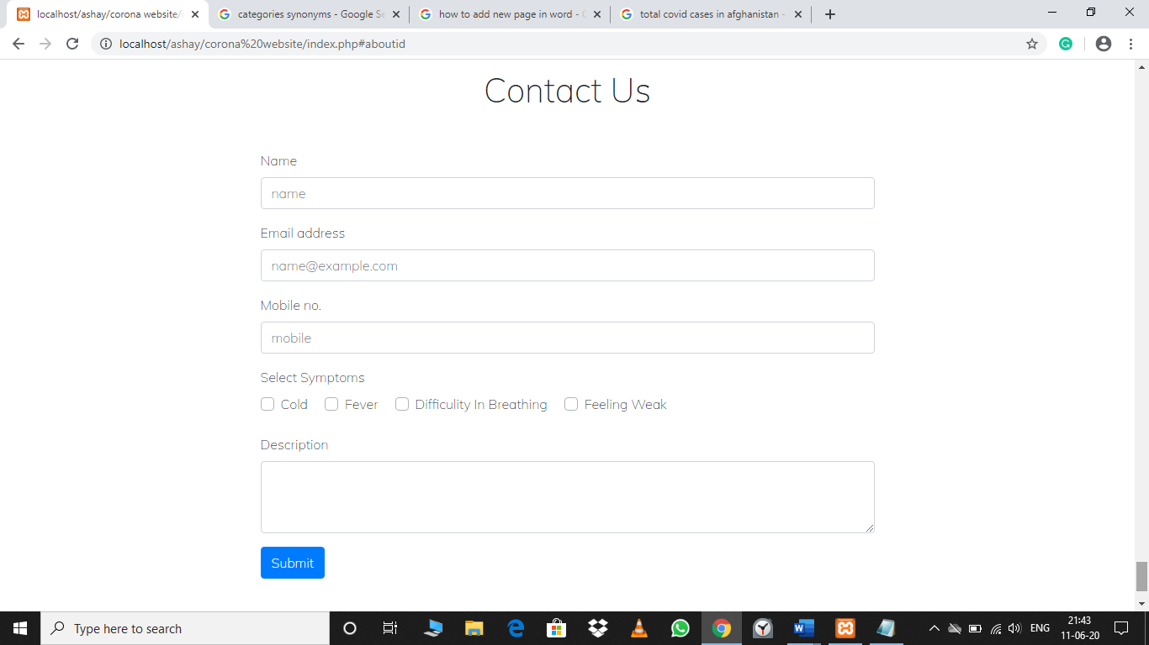

**12. DATABASE**

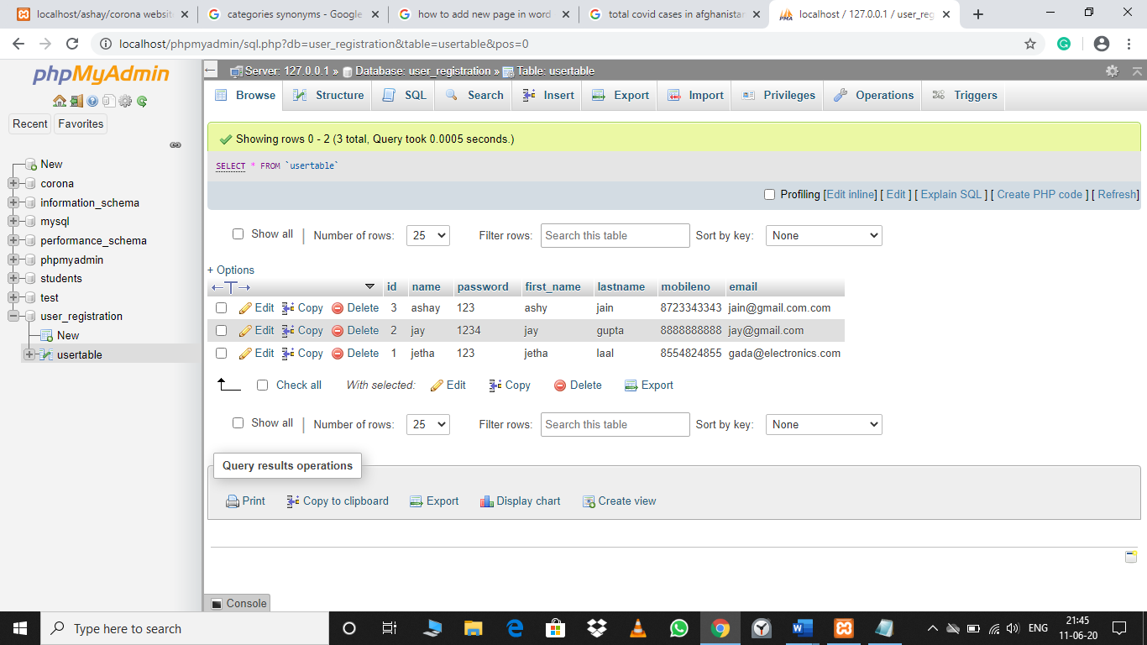

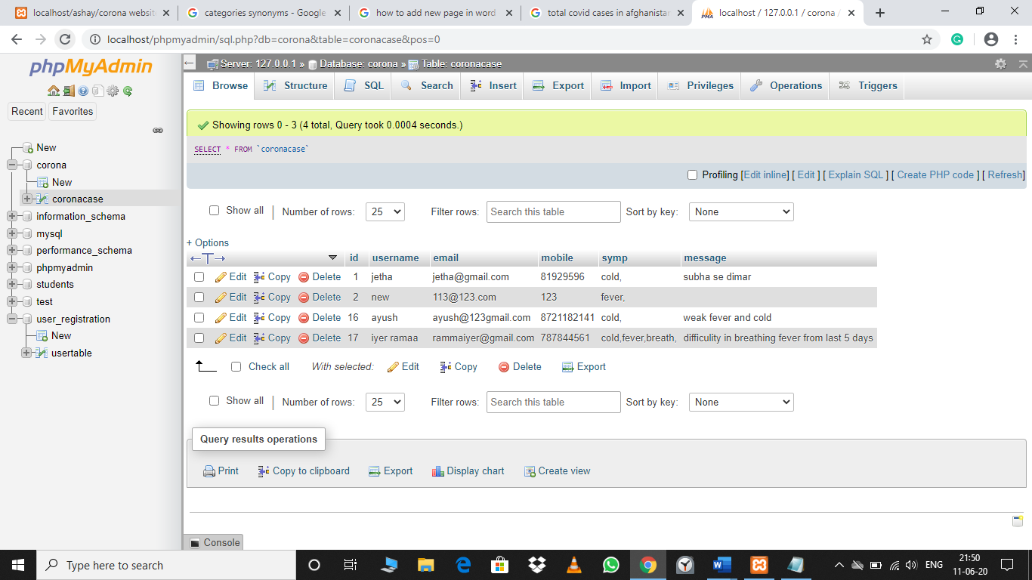

* + 1. Hardware Interface

All components able to be executes on personal computers with window OS platform and other platforms like Linux, Unix, Windows etc.

* + 1. Software Interface

All the interfaces will be html pages running within the internet browser. The data is stored in database with MySQL.

Frontend is created with the help of Notepad++, Adobe Dreamweaver.

Backend is done with the help PHP.



#### Functional requirements

* + 1. Login Module (LM)

User shall be able to load the Login module in the internet browser. The login module will support the user to log into the system. The login panel will contain fields to contain a user name and field for password. When the user clicks on login button the username and password will be verified by database administrator and then only user will be able to use the system function.

* + 1. Registered Users Module (RUM)

After successfully login, user will be able to continue navigating through the website and view the complete website.

* + 1. Server Module

Server module will be between the various modules and the DB. Server module will receive all request and format the pages accordingly to be displayed. Server module will validate and execute all request from the other module.

* 1. **Use Case**

User name

password

First name

Last name

Mobile no.

Email

password

Username

* 1. Non-functional requirements

Non-functional requirements may exist for the following attributes. Often this requirements must be achieved at a system wide level rather than at a unit level. State the requirements in the following sections in measurable terms

* + 1. Performance

The **Get Sports Info** will be built upon the web development technique and put on the web server online. The system and server must be capable of handling real time error functionality occurs by the defined users. In addition, the system must be safety critical. All failure reported by the server side must be handled instantaneously to allow for user and system safety,

* + 1. Reliability

The system is safety critical. If it moves out of normal operation mode. The requirement to drop to down the server and fix it as soon as possible and open it again. This emergency behavior will not occur without reason

* + 1. Availability

When in normal operating condition. Request by a user for an online system will be handled within 1 second. Immediate feedback of the system activities will be communicated to the user by clearing the system and giving space n speed to their hospitability.

* + 1. Security

There will be a strong security mechanism should be place in the server side of the system to keep unwanted user to hack or damage the system. However, all users of the system give and store the detail of privacy related to the personal information and many others.

* + 1. Portability

There is a portability requirement as far as our system is concern because it is an online as well as offline so we can access it from anywhere through the internet connection.

### ER-Diagram

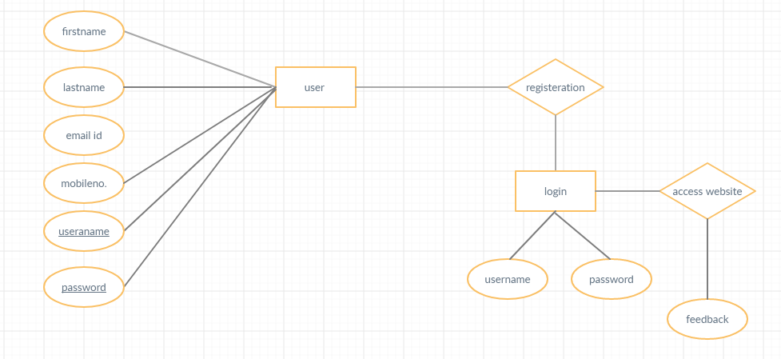

**3.6 Data Flow Diagrams**

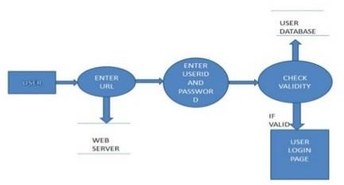

* + 1. **IMPLEMENTATION AND TESTING**

#### TESTING

Software testing is the most important phase in any software development project, so that we can know whether our project or product is going to be successful or it will fail before it goes live.

We can define software testing as process use to identify the quality of developed computer software, so that the developer of software can compare the results produced by the finished software and the expected one.

Though testing us cannot get totally bug free software we cannot achieve complete correctness through testing, but at least we can find some defects, which are there in there software. There are many, many different ways and levels to test software; here I am mentioning very basic and common levels of testing, which are usually done for all software. If the software is very complex or real time oriented than more levels van be added to the testing to achieve a reliable software product.

###### TESTING METHODOLOGY

Broadly software-testing levels are categorized into three levels.

1. Unit Testing
2. Integrating Testing
3. System Testing

###### TEST CASES

1 Unit Testing:

The smallest piece of software that can be tested in isolation to verify its behavior called a unit.

Unit Testing aims to testing each of the components that a system is built upon. Unit testing involves only those characteristics that are vital to the performance of the unit under test. This encourages

Developers to modify the source code without immediate concerns about how such changes might affect the functioning of other units or the program as a whole

2. Implement Testing

|  |  |  |  |  |  |  |  |  |  |  |  |  |
| --- | --- | --- | --- | --- | --- | --- | --- | --- | --- | --- | --- | --- |
| **S.No** | **Test Case** | **Objective** | | | **Steps & data** | | | **Expected** | | **Actual** | | **Status** |
| **Id** | **Result** | | **Result** | |
| 1 | TC_ES_1 | To | check | the | 1.Click |  | on | Login | | Successful | | Pass |
| functionality of login | | | Login |  |  | successfuly | | ly | login |
| with | valid user | id | 2..Enter | | user |  | and | and | home |
| and password | |  | Navigate to | | page |  |
|  | id | password | |
|  | |  | Home Page | | shown | |
|  | |  | like |  |  |
|  | |  | ashay@gmail.com | | |  | |  | |
|  | |  | S1234 |  |  |  | |  | |
| 2 | TC_ES_2 | To check the | |  | 1.Click |  | on | Error Msg | | Proper | | Pass |
| Functionality | | of | Login |  |  | Invalid | | error msg | |
| login with invalid | |  | 2..Enter | | user | Login | | Generated | |
| User id and password | | | id | password | | Stay on the | | On | login |
| like |  |  |
|  | | | ashay@gmail.com | | | login Page | | page |  |
|  | | |  |  |  |  | | while |  |
|  | | |  |  |  |  | | invalid | |
|  | | | 123 |  |  |  | | login |  |

**Methodology:** I have tested the functionalities of this system by running it and that will showing the results accordingly.

1. SYSTEM TESTING

System testing of software or hardware is testing conducted on a complete, integrated system to evaluate the system's compliance with its specified requirements. System testing falls within the scope of black-box testing, and as such, should require no knowledge of the inner design of the code or logic.

Apart from functional testing, other type of testing like, Performance, Security, Configuration installation etc is also performed during the system testing.

6. Conclusion and Future Enhancement

The system has been developed with simple user friendly, efficient and less time consuming. The overall data related to student is storing in proper data base.

Good record keeping is important for many reasons ranging from continuity of excellent care to data to support hostels . Hostel Record are particularly good at keeping records of the work they do to ensure that nothing is overlooked and there is something for others to refer to.

Once the information is no longer needed, however, it should be disposed.

**A**. **Appendices**